**IOT PROJECT**

**(2020-2021)**

**IOT BASED VEHICLE TRACKER USING GOOGLE MAP (NODE MCU)**

**REPORT**



**Institute of Engineering & Technology**

**Submitted by PRIYANSHU SHUKLA**

**(181500515)**

**DIVYANK GUPTA**

**(181500221)**

**RAJ GUPTA**

**(181500542)**

***Supervised By: -***

**Mr. Ajitesh sir**

**Department of Computer Engineering & Applications**

**Declaration**

I hereby declare that the work which is being presented in the Project **“Vehhicle Tracker Using Google Map Using Nodemcu ”,** in partial fulfillment of the requirements fori project Lab is an authentic record of our own work carried under the supervision of **Mr. Ajitesh Sir**

**Priyanshu Shukla**

**Divyank Gupta**

**Raj Gupta**

### ACKNOWLEDGEMENT

It gives us a great sense of pleasure to present the report of the Project Work, undertaken during

B. Tech. Final Year. We owe special debt of gratitude to **Mr.Ajitesh Sir,** Department of Computer Science &Technology, GLA University, we are thankful for his constant support and guidance throughout the course of our work. His sincerity, thoroughness and perseverance have been a constant source of inspiration for us. It is only his cognizant efforts that our endeavors have seen light of the day.We also do not like to miss the opportunity to acknowledge the contribution of all faculty members of the department for their kind assistance and cooperation during the development of our project. Last but not the least, we acknowledge our friends for their contribution in the completion of the project.

Signature:

Name :

Roll No.:

Date:

Signature:

Name :

Roll No.:

Date:

Signature:

Name :

Roll No.:

Date:

**Content**

1. **Abstract**
2. **About this project**
3. **Working of the project**
4. **Layout diagram**
5. **Component required**
6. **Code explanation**
7. **Objective of the project**

**Abstract:**

In this fast life, everyone is in hurry to reach their destinations. People who rely on the public transport their major concern is to know the real time location of the vehicle for which they are waiting for and the time it will take to reach their bus stop.

This information helps people in making better travelling decisions. Now a day’s people are not aware of exact timing and location of the vehicles for easy transportation. So we planned to implement to a smart vehicle tracking system for easy transportation facility using IoT. By knowing the location of the vehicle, lot of the time will be saved.

**About the project:**

Vehicle tracker system becomes most important in this time especially in case of stolen vehicle. if you have gps system setup in your vehicle you can track location where is your vehicle. it helps police to track stolen vehicle .

In this project gps module used for finding the location cordinates .and wifi module used for to keep send data to computer or mobile through wifi.

**Working of the project:**

To Track the vehicle ,we require/need to find the coordinates of vehicle using GPS module .GPS module consecutive with the satelite for finding the cordinates .

Then we need to send these coordinates from GPS to our Arduino . then Arduino extract the required data from accepted data by GPS .

**Layout of project :-**

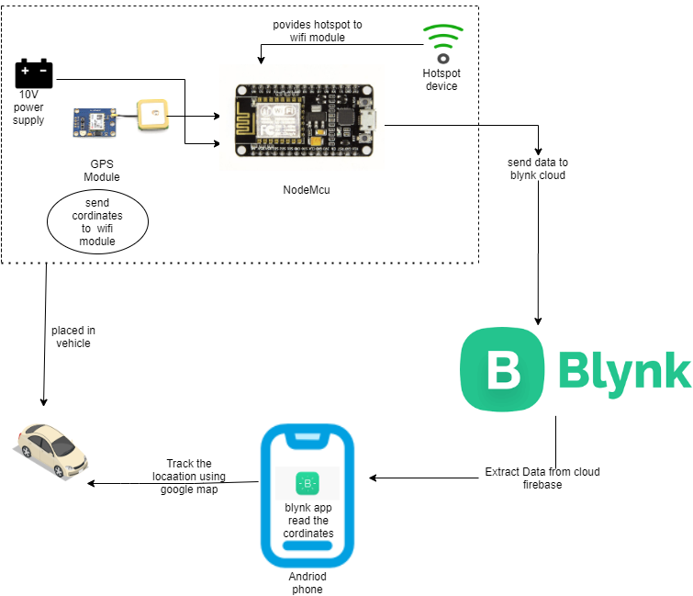

**Components required:**

1-Node MCU

2-Wifi module ESP8266

3-Gps module

4-jumper wires

5-Laptop

6-Power supply

7-16*2 LCD

**Code explanation:**

In this project code we used serial software library to interface ESP8266 and gps module with Nodemcu ,then we have described different pins for both and UART with 9600 buad rate also installed liquid Crystal library for interface LED with Nodemcu . ow its time to program the esp8266 node mcu .

Start code including all the required library files in the code exp- ESP8266wifi.h for

LCD.

#include <TinyGPS++.h>

#include <SoftwareSerial.h>

#define BLYNK_PRINT Serial

#include <ESP8266WiFi.h>

#include <BlynkSimpleEsp8266.h>

static const int RXPin = 2, TXPin =0 ; // GPIO 4=D2(conneect Tx of GPS) and GPIO 5=D1(Connect Rx of GPS)

static const uint32_t GPSBaud = 9600; //if Baud rate 9600 didn't work in your case then use 4800

TinyGPSPlus gps; // The TinyGPS++ object

WidgetMap myMap(V0); // V0 for virtual pin of Map Widget

SoftwareSerial ss(RXPin, TXPin); // The serial connection to the GPS device

BlynkTimer timer;

float spd; //Variable to store the speed

float sats; //Variable to store no. of satellites response

String bearing; //Variable to store orientation or direction of GPS

char auth[] = "8ooZn_iFvjaL1Gk2enWMkwX22IkRCqnP"; //Your Project authentication key

char ssid[] = "I"; // Name of your network (HotSpot or Router name)

char pass[] = "55475547"; // Corresponding Password

//unsigned int move_index; // moving index, to be used later

unsigned int move_index = 1; // fixed location for now

void setup()

{

Serial.begin(115200);

Serial.println();

ss.begin(GPSBaud);

Blynk.begin(auth, ssid, pass);

timer.setInterval(5000L, checkGPS); // every 5s check if GPS is connected, only really needs to be done once

}

void checkGPS(){

if (gps.charsProcessed() < 10)

{

Serial.println(F("No GPS detected: check wiring."));

Blynk.virtualWrite(V4, "GPS ERROR"); // Value Display widget on V4 if GPS not detected

}

}

void loop()

{

while (ss.available() > 0)

{

// sketch displays information every time a new sentence is correctly encoded.

if (gps.encode(ss.read()))

displayInfo();

}

Blynk.run();

timer.run();

}

void displayInfo()

{

if (gps.location.isValid() )

{

float latitude = (gps.location.lat()); //Storing the Lat. and Lon.

float longitude = (gps.location.lng());

Serial.print("LAT: ");

Serial.println(latitude, 6); // float to x decimal places

Serial.print("LONG: ");

Serial.println(longitude, 6);

Blynk.virtualWrite(V1, String(latitude, 6));

Blynk.virtualWrite(V2, String(longitude, 6));

myMap.location(move_index, latitude, longitude, "GPS_Location");

spd = gps.speed.kmph(); //get speed

Blynk.virtualWrite(V3, spd);

sats = gps.satellites.value(); //get number of satellites

Blynk.virtualWrite(V4, sats);

bearing = TinyGPSPlus::cardinal(gps.course.value()); // get the direction

Blynk.virtualWrite(V5, bearing);

}

Serial.println();

**Main objective:**

* This system is very efficient for outdoor application purpose.

*This kind of vehicle tracking system project is widely in tracking cabs/ taxis/ ,stolen

vehicles, school/college buses etc.